OF CORPUS CHRISTI CATHOLIC CHURCH
3550 E. KNOX ROAD PHOENIX, AZ 85044 480-893-8770
http://WOMENSSODALITY.WEEBLY.COM
JANUARY 2016 NEWSLETTER

MERRY CHRISTMAS, HAPPY NEW YEAR and HAPPY EPIPHANY!!
We hope you all had a blessed holiday
season with your friends and family.

WELCOME - Thank you so much for taking time out of your evening to be with us.

DUES - If you have not paid your dues yet, please do so tonight. Cost for the year is $25.00. Thank you.

OUR THEME FOR THE YEAR IS MERCY
All speakers will be talking about MERCY in some way and how we can show MERCY to others for the “YEAR OF MERCY.”

DECEMBER RECAP – Fun was had by all AT THE MONTHLY meeting as we feasted on Mexican food and all went home with cookies and a new ornament from the exchange. Jessica, a student of Barb’s played piano during our social hour and Barb played for us while Vera led us in singing Christmas carols. Many THANKS to the ladies that brought nonperishable food for St. Vincent de Paul.

THANKS to those that bought a ticket(s) and supported the Christmas Gala! The dinner and entertainment was excellent! If you couldn’t make it, you missed a great event!! THANKS to the ladies that bought and sold poinsettias in December.

JANUARY MEETING – Speaker Alcira Pastula, Parish and Community Engagement Coordinator from Catholic Charities Community Services on the Corporal Works of Mercy. Donations brought for Women Veterans StandDown 2016.

FEBRUARY MEETING – Bring a wrapped gift for the pink elephant exchange. This is a new or gently used item you have at home that you no longer want or need.

REMAINING MEETING DATES 2016
February 3, 2016 - Ice Cream Social and pink elephant exchange
March 2, 2016 - Speaker on Spiritual Works of Mercy and Bingo
April 6, 2016 - Speaker on Divine Mercy and elections
May 4, 2016 - Installation of officers and year end celebration

UPCOMING EVENT
April 16, Saturday – High Tea at Four Points by Sheraton, cost $25 each.
Plan on attending now. Tickets go on sale at the February meeting.
REMEMBER TO PRAY FOR YOUR PRAYER PARTNER !

2015 - 2016 OFFICERS
REGINA LYNDE - PRESIDENT 480-759-5719 EMAIL: WSCCCCPRESIDENT@GMAIL.COM
ANITA HAYES - VICE PRESIDENT 480-598-8747 EMAIL: WSCCCCVICEPRESIDENT@GMAIL.COM
SHARON OLSEN - SECRETARY/TREASURER 602-573-5212 EMAIL: WSCCCCSECRETARY@GMAIL.COM
MORE INFORMATION on CHARITIES FROM TONIGHT

Catholic Charities Community Services
4747 N. 7th Ave.
Phoenix, AZ 85013
O:602-650-4832
www.catholiccharitiesaz.org
Be a Tax Credit Champion and donate to Catholic Charities! Learn more!

Welcome to Catholic Charities
Since 1933, Catholic Charities and people like you have helped millions of vulnerable people in Arizona. Together, we are helping miracles to happen every day in our communities. Please sign up for our newsletter to read these life-changing stories happening right where you live.

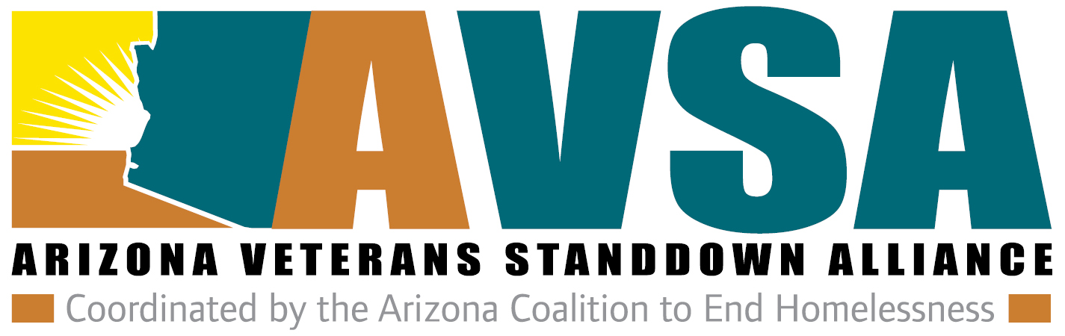

http://www.arizonastanddown.org/maricopa

2016 Maricopa County StandDown
28 Jan 2016 7:00 AM to 29 Jan 2016 at 5:00 PM
  - Location
Veterans Memorial Coliseum, 1826 W. McDowell Road, Phoenix, AZ 85007
- The 2016 Maricopa County StandDown will take place January 28-29. You can sign up to volunteer online.

The 2015 Maricopa County StandDown, which was held at the Veterans Memorial Coliseum February 12-14, 2014, was the largest, singular outreach event for homeless veterans in the country in 2015. The newly formed Arizona Veterans's StandDown Alliance, which supports all eight annual StandDown's throughout the state under the 501c3 of the Arizona Coalition to End Homelessness, relies heavily on contributions from the public to support over 2,500 veterans annually.While the primary goal is to help homeless veterans access resources, including housing, its secondary goal is to bring community and service providers together in a collaborative format to build relationships throughout the year to benefit homeless and at risk veterans.

